10 Way Vertically Mounted Rackmount 32A Commando PDU - UK Sockets (PDU-10WS-V-32CMDO)
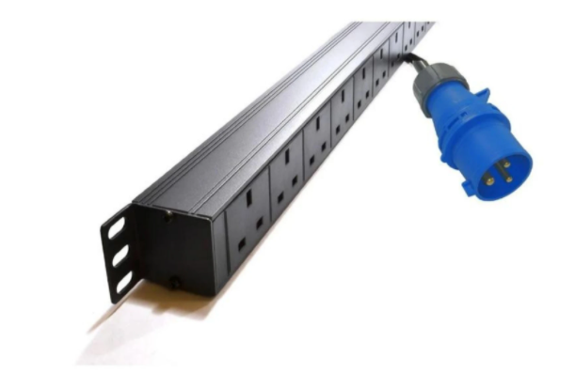

Description:

The LMS Power PDU-10WS-V-32CMDO is a high-quality vertically mounted PDU (Power Distribution Unit) that simply fits within the universal mounting brackets of data, telecom and server cabinets.

A must-have accessory for your data cabinets if you need to provide effective power to devices including Ethernet Switches, Servers, UPS, NAS and of course cabinet accessories including cooling fan trays.

Robust, alloy design complete with rackmount brackets fitted, high-quality Neon Switch and of course UK output sockets together with a high quality, 32-Amp rated extra heavy duty Commando power input plug, ideal for industrial usage.

Key Features:

Standard UK 3-Pin power outlets for your appliances
Extra HD 32 Amp Commando Plug for industrial applications
1U high means the PDU can fit into the smallest cabinet
Neon On/Off Rocker switch to prevent accidental turn off
Backed up by LMS Power's exclusive 3-year warranty

Applications:
Create instant power feeds to your data, telecom or server cabinets
Provide effective power for cabinet cooling fans, UPS systems
Ideal as stand-alone trailing sockets outside the cabinet

Product Code:
Part Number: PDU-10WS-V-32CMDO
EAN: 8400800032027
Weight: 1.7Kg approx

Technical Specifications:
Warranty LMS Data 3-Year Warranty
Chassis 1U vertical mount with mounting brackets
Output Sockets 10 UK 3-PIN Sockets
Power Input Fitted 32-Amp HD Commando Plug
Flex Length 1.8 metres (approx)
Power Control On/Off Rocker Switch (illuminated)
Power Rating 4000 Watts (approx)

Supplied With:
PDU-10WS-V-32CMDO 10 Way Vertical PDU
19-inch cabinet brackets (Fitted)
* Specifications and product design are subject to change. E&OE.

Looking for highperformance power distribution for your heavily loaded systems? The newly developed LMS Data 16A heavy-duty vertical PDU is ideal for highloading device requirements including server, network and other industrial-type equipment functions such as broadcast and HVAC applications. Combining a fully certified commando type 16A plug input combined with a compatible heavy load power flex means you can be assured this LMS Data PDU can work without problems, 24/7. Furthermore, incorporated onto the vertical form-factor are industry standard UK 3-pin sockets, ideal for data, telco and broadcast equipment. Robust in design, with an integral neon illuminated rocker switch for assured functionality, the LMS Data PDU is designed to deliver maximum electrical power today and tomorrow.

specifications:
Vertical, high-performance Power Distribution Unit (PDU)
Heavy-load 16A Commando style 3-pin plug
Compatible, heavy-load power cable
10x UK style output power sockets
Robust, black aluminium design for industrial use
Neon on/off power switch for assured control
Maximum power rating - 4000W
2.0 metre (approx.) power cordage
Ideal for data, telecom, broadcast and HVAC applications

